Mega noughts and crosses

Instructions
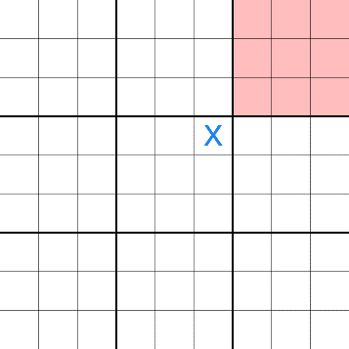
Mega noughts and crosses is a pen and paper game with nine mini noughts and crosses boards arranged in a larger 3-by-3 grid.
The game starts with X playing wherever they want in any of the 81 empty squares. However the position of the square they choose dictates which mini-game their opponent has to play in next. For example, if X plays in the top-right square of the middle mini-game (see image), O then must play the top-right mini-game; O then sends X to the mini-game of their choice and so on. It takes about 20-30 moves before it really starts to get tactical so be patient and think where to send your opponent so that you get to win, and above all have fun!
Getting a line of three in a mini-game means you win that square in the global game. Get a line of three in the global game or win the greatest number of mini games to win overall.

